**Degsin data pipeline**

**Model and idea**

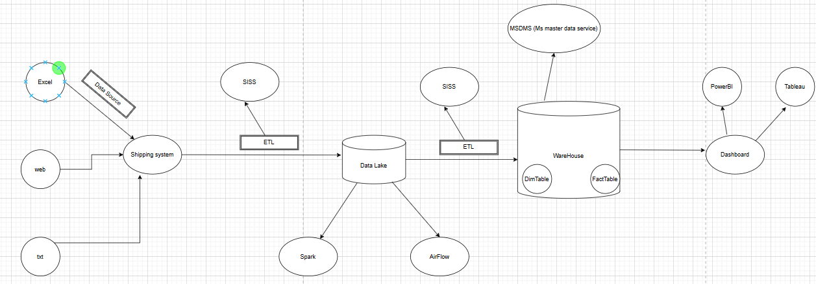

Instructor give me an idea about design data warehouse model it include:

- Get available data of company to design a shipping system

- Extract, tranform and load it to data lake

- Then ETL it into dataware house and finally visualization it on dashboard

**I. Design Dim and Fact model**

First i using draw.io to design dim and fact table when i have data from intructor

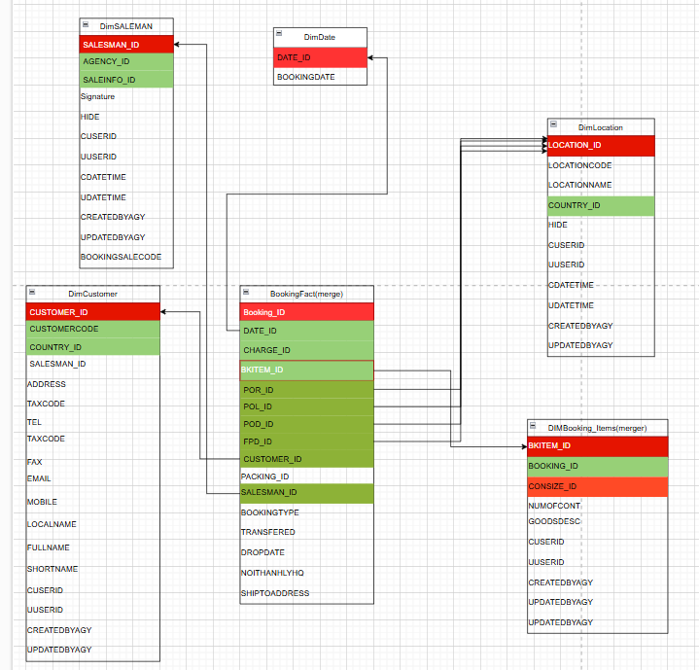

**Pic1:** model dim and fact table

This is Dim and Fact table

Because data very large i don’t have enough time to do so intructor give some table on pic1 for me to practice.

**II. Extract, tranform and load data:**

- My idea is get data from source ETL it into Staging layer and check any problem with my data and finally give it into Warehouse layer

- I use Micrsoft SISS to work it’s a tool of microsoft can help me etract, tranform and load data into to stagging layer.

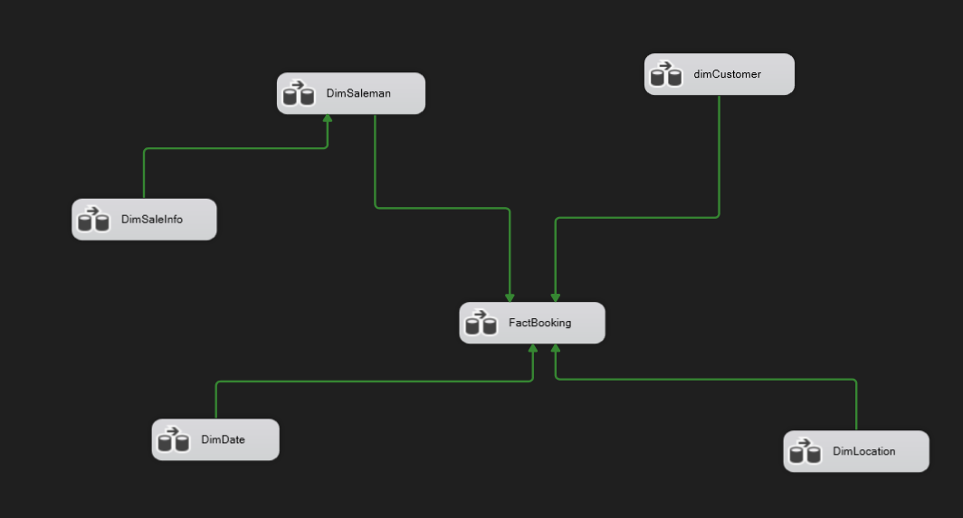

**Pic2:** get data from source to staging layer

- I get data from source and transform it to staging layer and load it to sql server database

- I use some query to find any problem in data. If it do not any problem similar pic2 I will ETL it to data warehouse

**III. Query in SQL**

After complete ETL data from data warehouse I use sql server to query some request in that data like:Service customer, Customer count, Sum avenue, avenue saleman, name of sale man,….

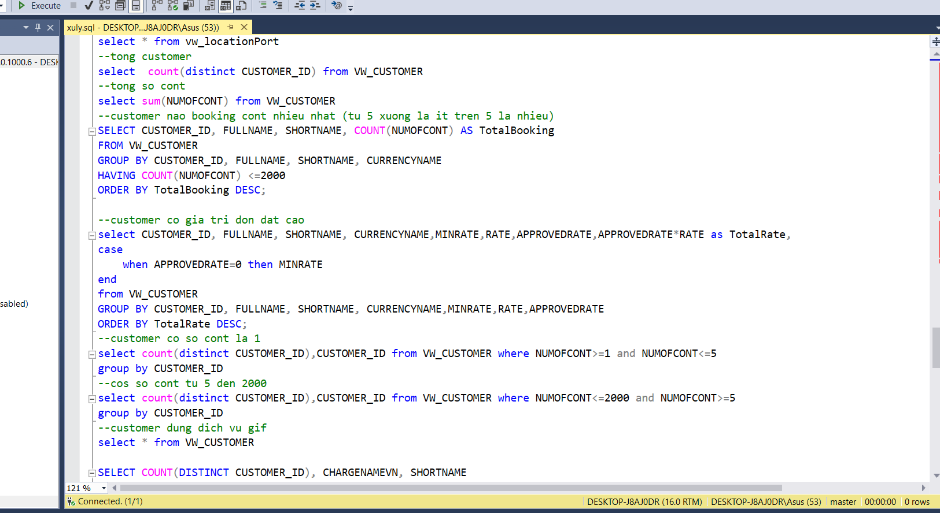

**Pic3:** Example some query in sql server

**IV. Visualization on dashboard**

Finally when complete query I use power Bi to visualize data from dashboard

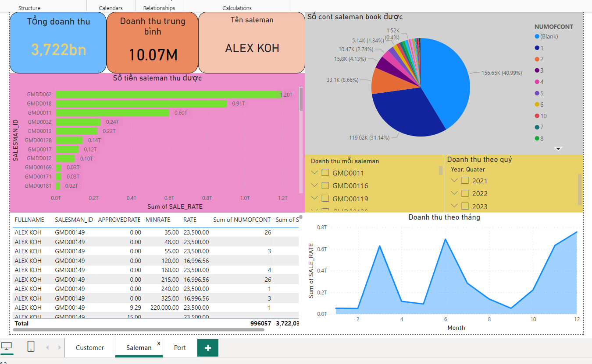

**Pic4:** Example dashboard of saleman